Week 9 Lab

Dylan Rodwell: 105431089

# 9.1.1(a)

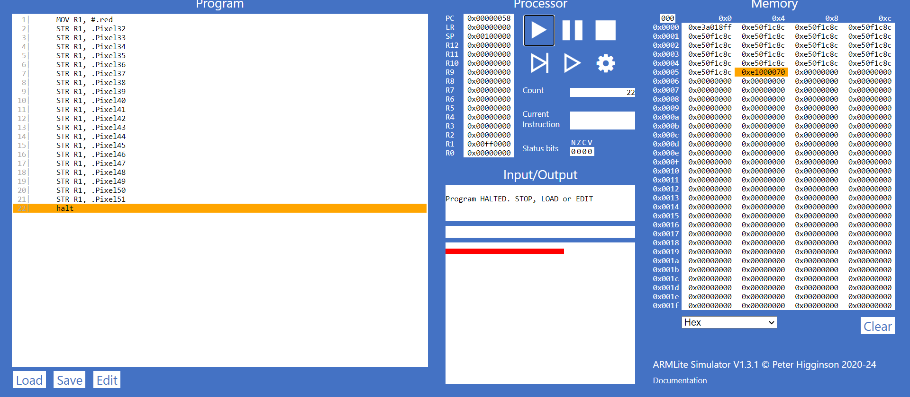

# 9.1.1(b)

# 9.1.2

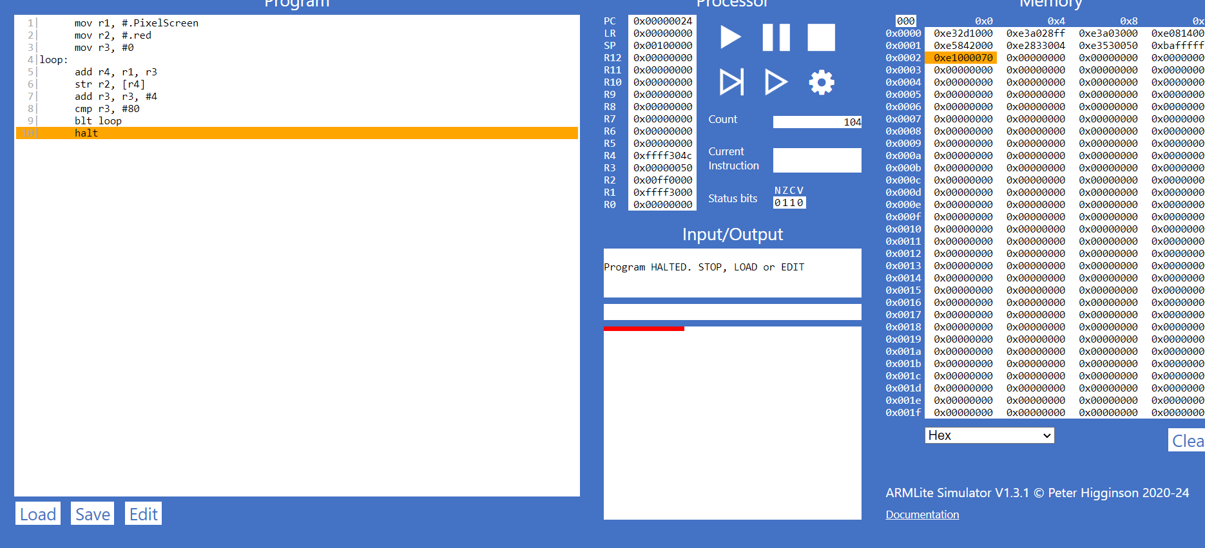

Looked over the code

# 9.1.3(a)

The code is an example of indirect addressing because the address is first looked up then is used to locate the data

# 9.1.3(b)

# 9.1.3(c)

  1|      mov r1, #.PixelScreen

  2|      mov r2, #.red

  3|      mov r3, #128

  4|loop:

  5|      add r4, r1, r3

  6|      str r2, [r4]

  7|      add r3, r3, #256

  8|      cmp r3, #5248

  9|      blt loop

 10|      halt

# 9.2.1

# 9.2.2

# 9.3.1(a)

Using .Align 256 will store the information in the next byte that is divisible by 256